**MUSICAL THEORY ASSETS:**

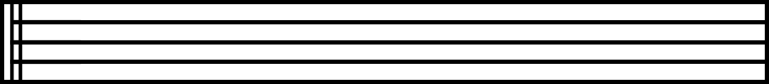

*Pentagram (1500x500)*

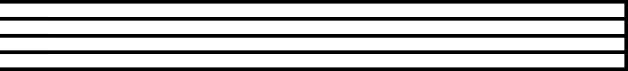

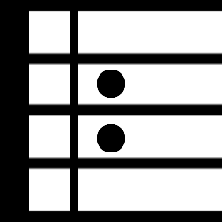*PentagramNoStart (1500x500)*

*Pause Pentagram 1 Left (1000x400)*

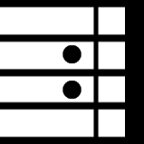

*Pause Pentagram 2 Left (1000x400)*

*Stop Pentagram (1024x1024)*

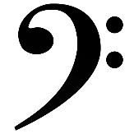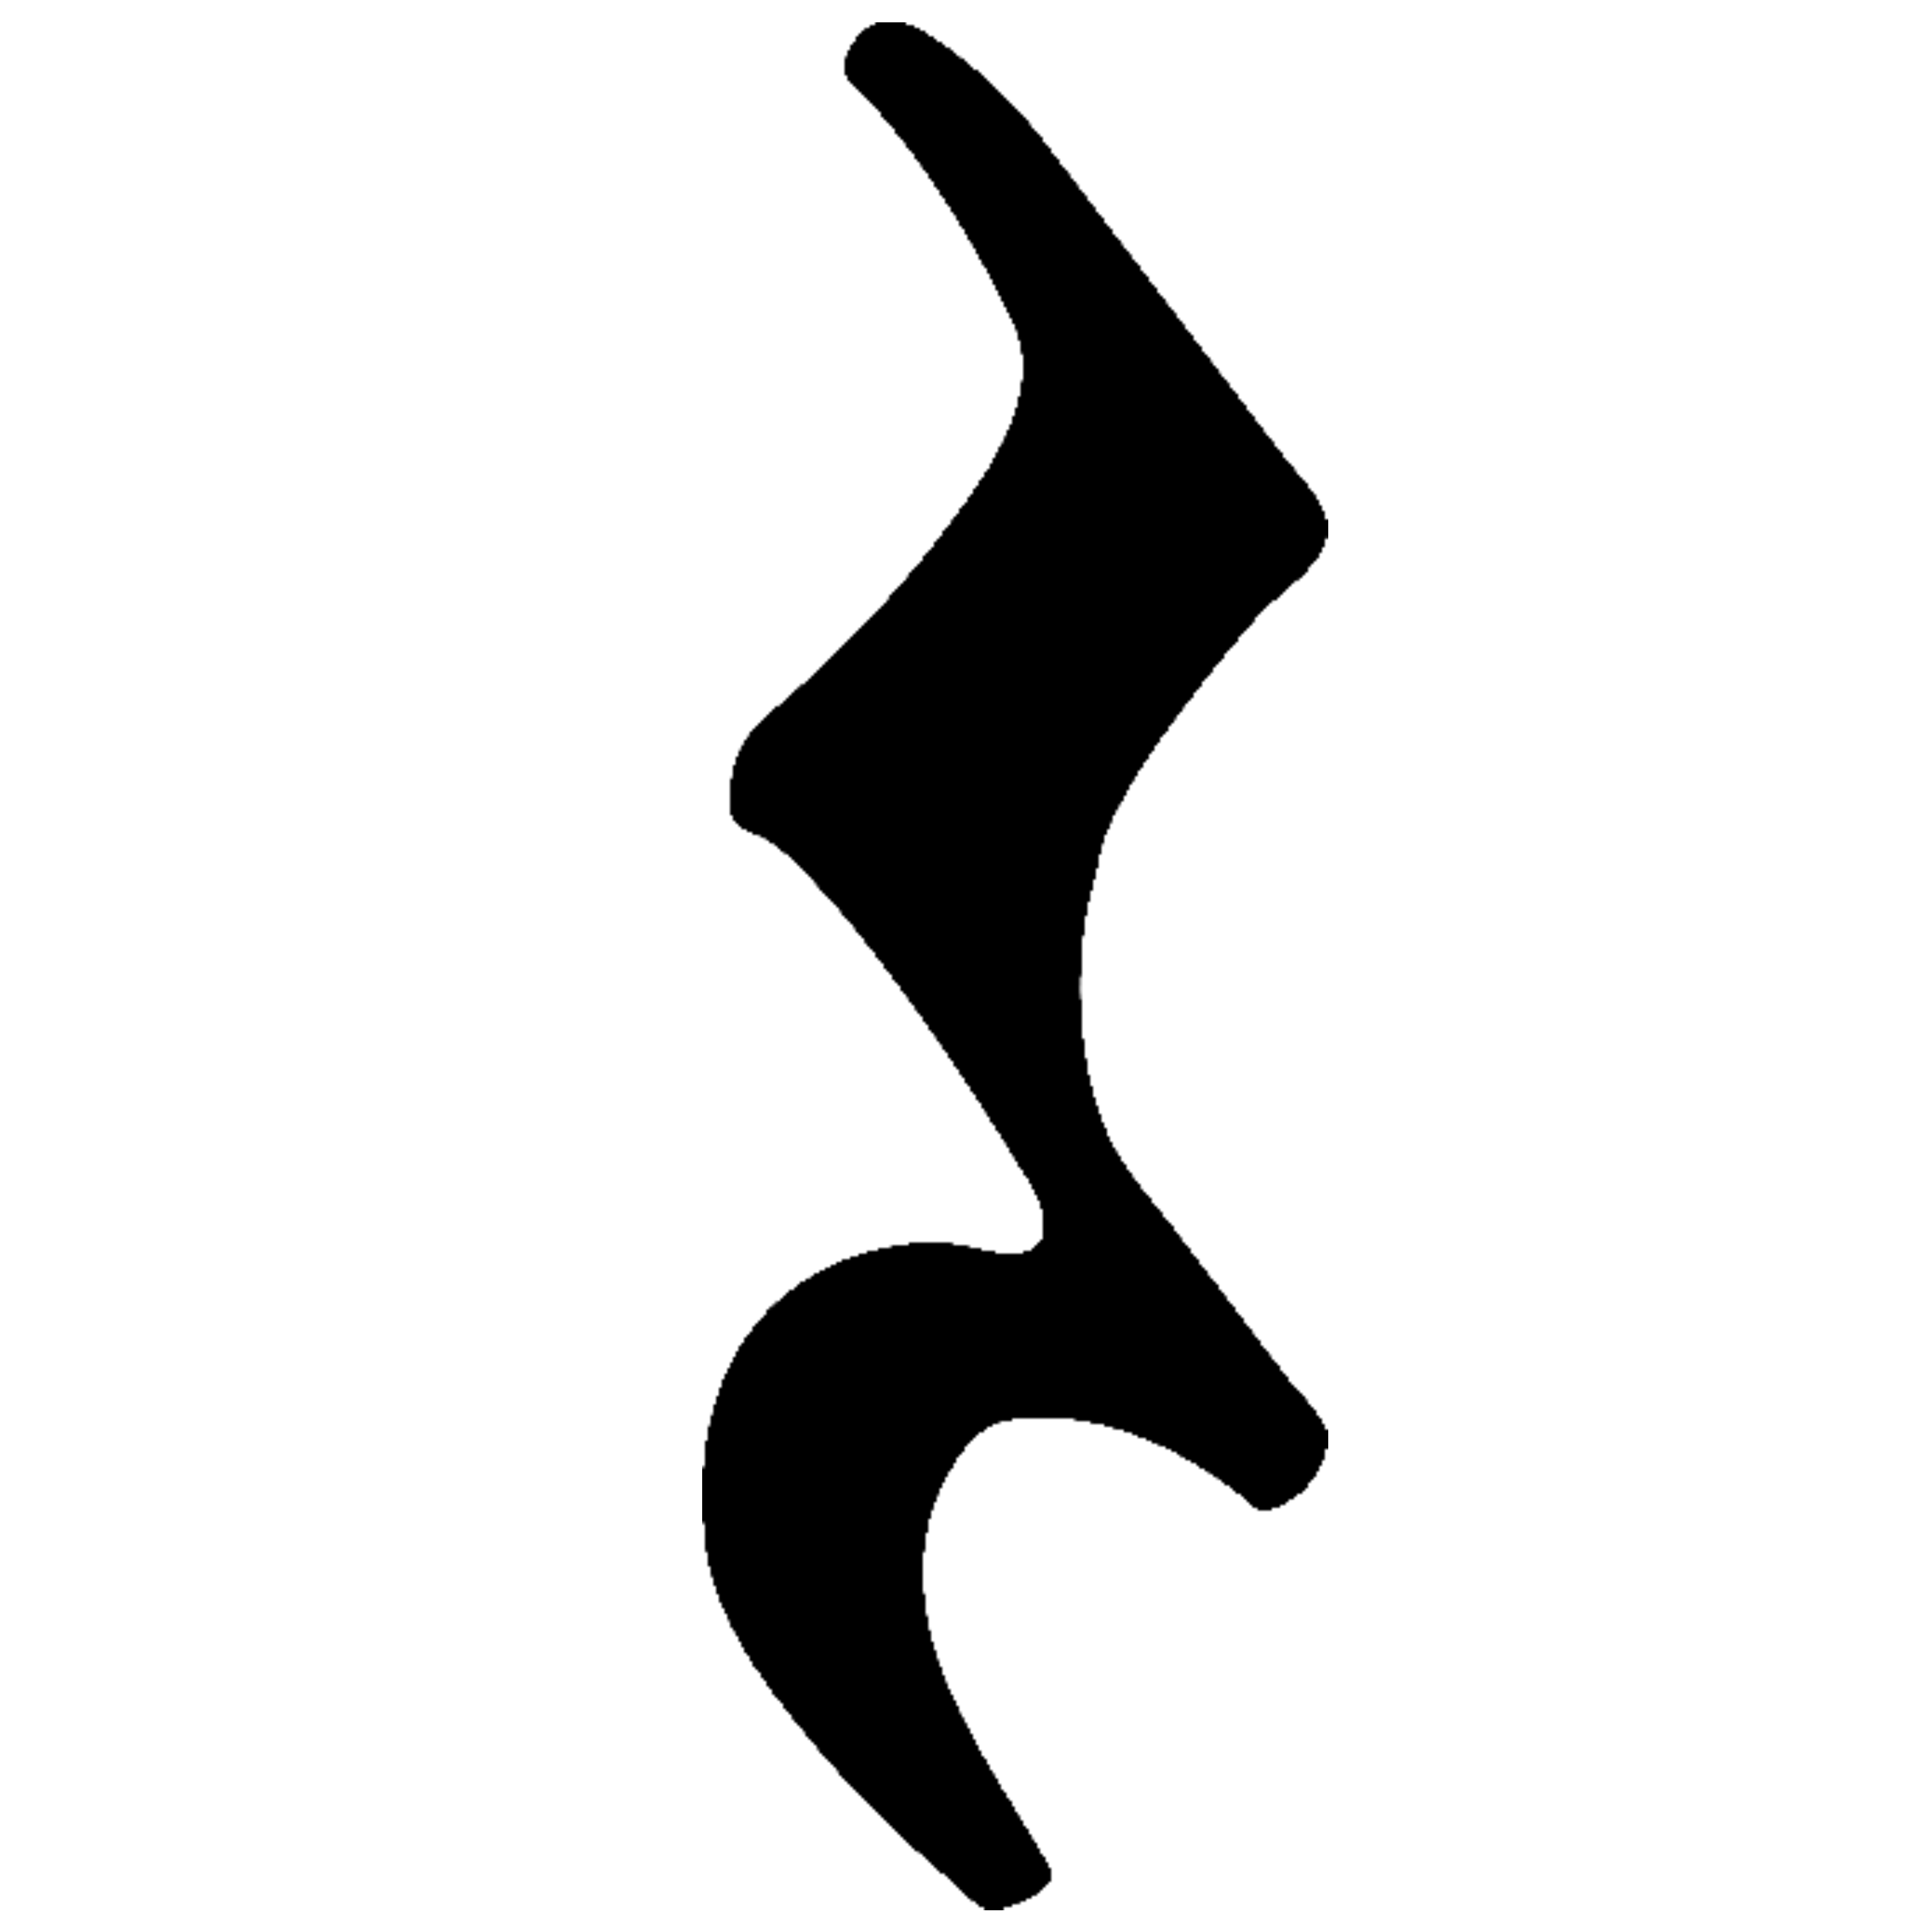

*Clef #1 (2048x2048) Clef #2 (2048x2048)*

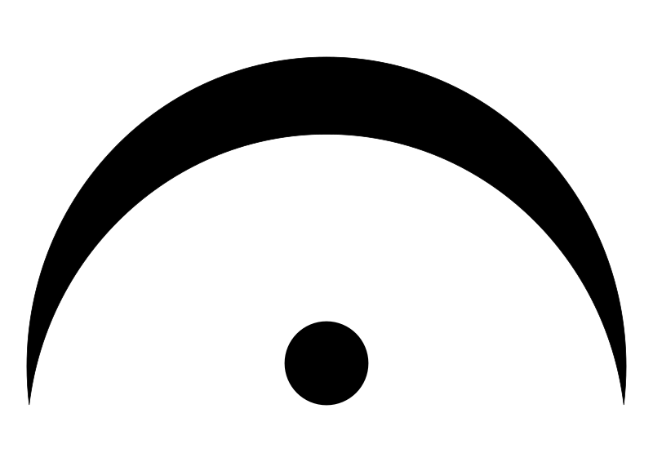

*Pause #1 (2048x2048) Pause #2 (2048x2048)*

*Types of Notes that will be used*

**CHARMS ASSETS:**

* Docs Link: <https://docs.google.com/document/d/1j63Vyf2Y5lmI1AhjYbIEeK6iXEz2Un7fWV_2KwbALg4/edit?tab=t.0>

List:

* + [Cornino](https://www.aquamarinagioielli.com/prodotto/charm-cornino-coccinella-piccolo-rosso/) (2048x2048)
  + [Small Bottle of Olive Oil](https://cdn.shopify.com/s/files/1/0561/3553/files/two_olive_oils.jpg?v=1652881932) (2048x2048)
  + [Golden Arancino](https://www.seriouseats.com/arancini-rice-balls-recipe) (2048x2048) [But made out of gold]
  + [Glass Cassata](https://bake-street.com/cassata-siciliana/) (2048x2048) [But made out of glass]
  + [Marble Cannolo](https://es.wikipedia.org/wiki/Cannolo#/media/Archivo:Cannolo_siciliano_with_chocolate_squares.a) (2048x2048) [But made out of marble]
  + [Ancestral Limoncello](https://www.alticciowinestore.co.uk/products/bottega-limoncino-limoncello) (2048x2048)
  + [Masaniello’s Coppola](https://en.wikipedia.org/wiki/Coppola_cap#/media/File:Modelli_di_coppole.jpg) (2048x2048) [darkish red, velvety color]
  + [Broken Scacciapensieri](https://it.wikipedia.org/wiki/Scacciapensieri#/media/File:Jew's_harp.") (2048x2048)
  + [Old Friscalettu](https://musicaparaver.org/instrumentos/friscalettu) (2048x2048)
  + [Sacred Ring](https://i.etsystatic.com/23847072/r/il/c5d547/6294909494/il_1080xN.6294909494_uu9e.jpg) (2048x2048)
  + [Wine Chalice](https://m.media-amazon.com/images/I/71MZMyTG5PL.jpg) (2048x2048)
  + [Trinacria](https://www.oursicily.com/wp-content/uploads/2023/02/trinacria1.jpg) (2048x2048)

**MASKS ASSETS:**

* Docs Link: <https://docs.google.com/document/d/1M92h9InAxY1rRCE-EuTwBMKS4RTKdFovH_Gx1SR56W4/edit?tab=t.0>
* Mask of the Zanni
* Mask of Coviello
* Mask of Dosseno
* Mask of the Abbatazzu

**BAROQUE ORNAMENTATION:**

Examples:

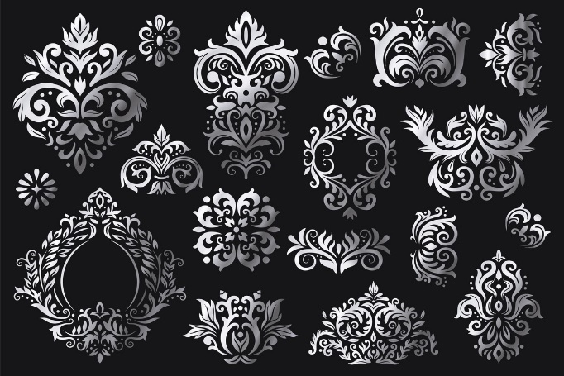

*Example of ones that could be placed as random decorations*

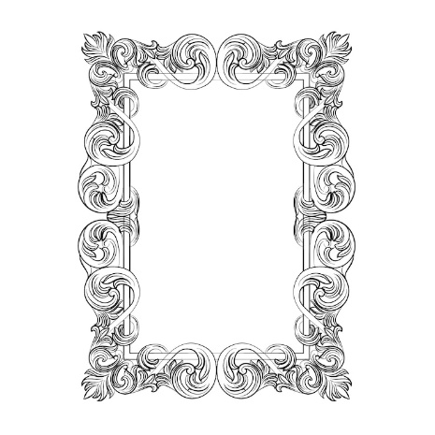

*Example of one that would be used for the “framing” of slots in the inventory and/or HUD*

Also try to aim for corner, bottom and side ones, so that they can be added in the Menu screens

Remember that we are looking for subtle and hand drawn type of style, something like this, and even a little more subtle:

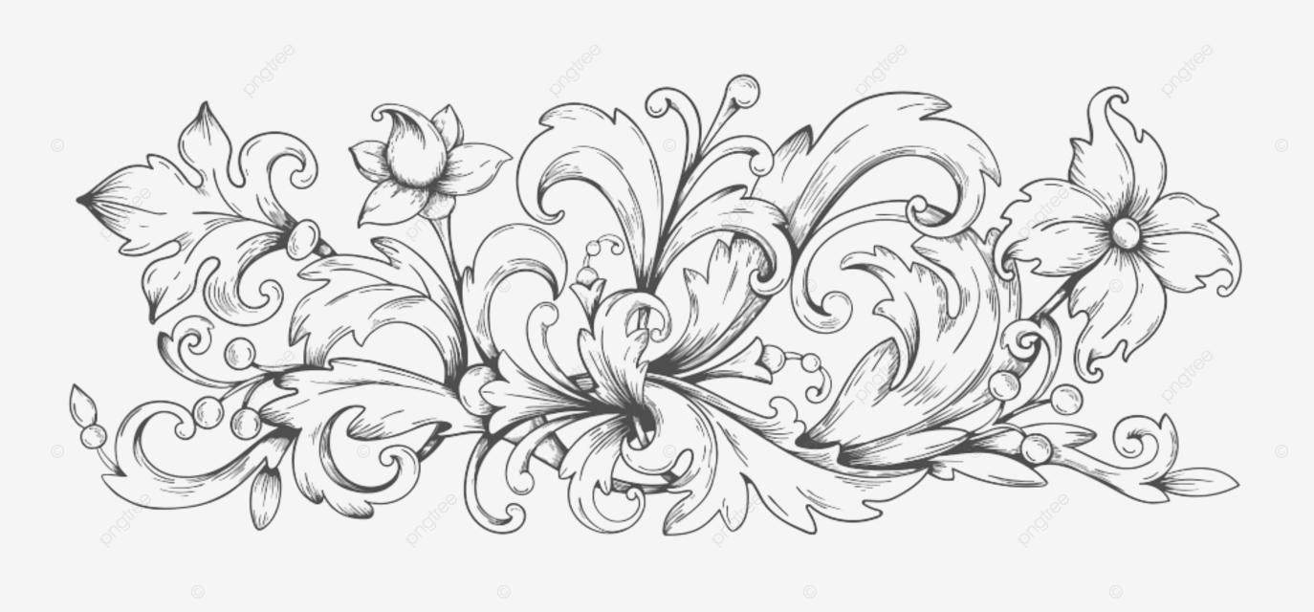

If you can also make a old paper texture like the ones we are using for the game currently, that would be great, because the one we are currently using is from the internet. It would be great if you can also make details like wrinkles and things like that in the corners to add more depth to the texture.

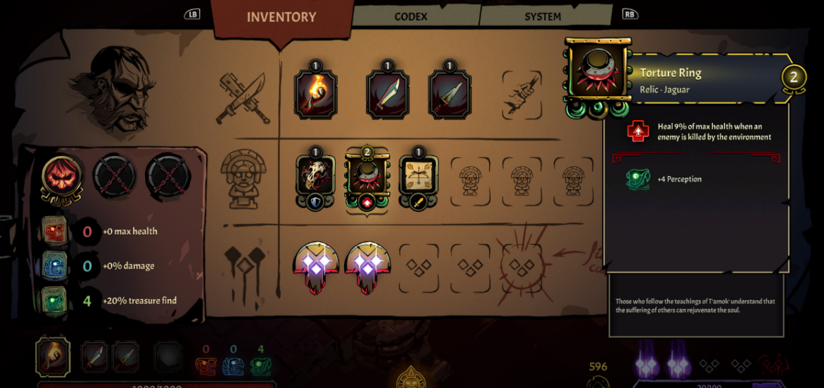Something like this:

And for this part if you can make something like maybe a smudge, or extra layer of old paper but darker, and that has more wrinkles and things like that in the sides to be able to see that is another layer:

Finally, we also need controller and keyboard and mouse iconography, something like this in dark brownish colors for all the buttons in the controllers (Xbox and PlayStation) and for Keybaord we can stick for now with WASD, Arrow Keys, Space bar, left click mouse, right click mouse, mouse movement, Shift Key, Esc Key.

This is an example of the look of it in terms of outline and fill, but remember, subtle and hand drawn style (Icons should be 2048x2048):

